Assignment-1

Task-1

#Python program to calculate the factorial of number using a loop(no fuction)

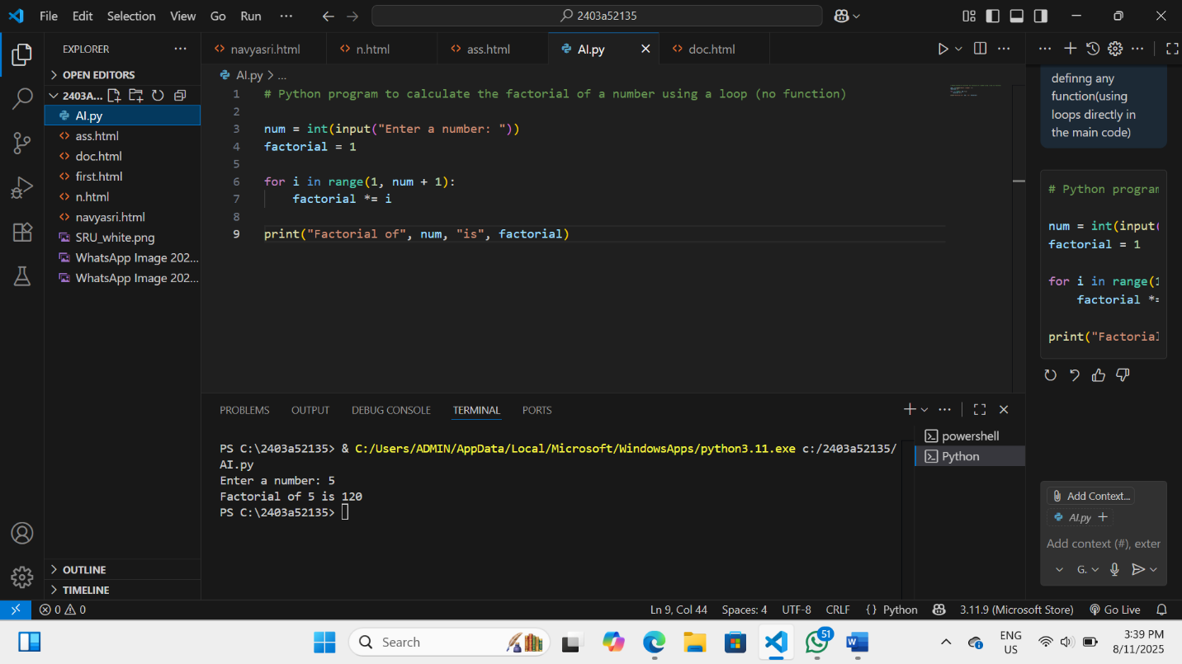

Task-3

#Python program to calculate the factorial of number using function

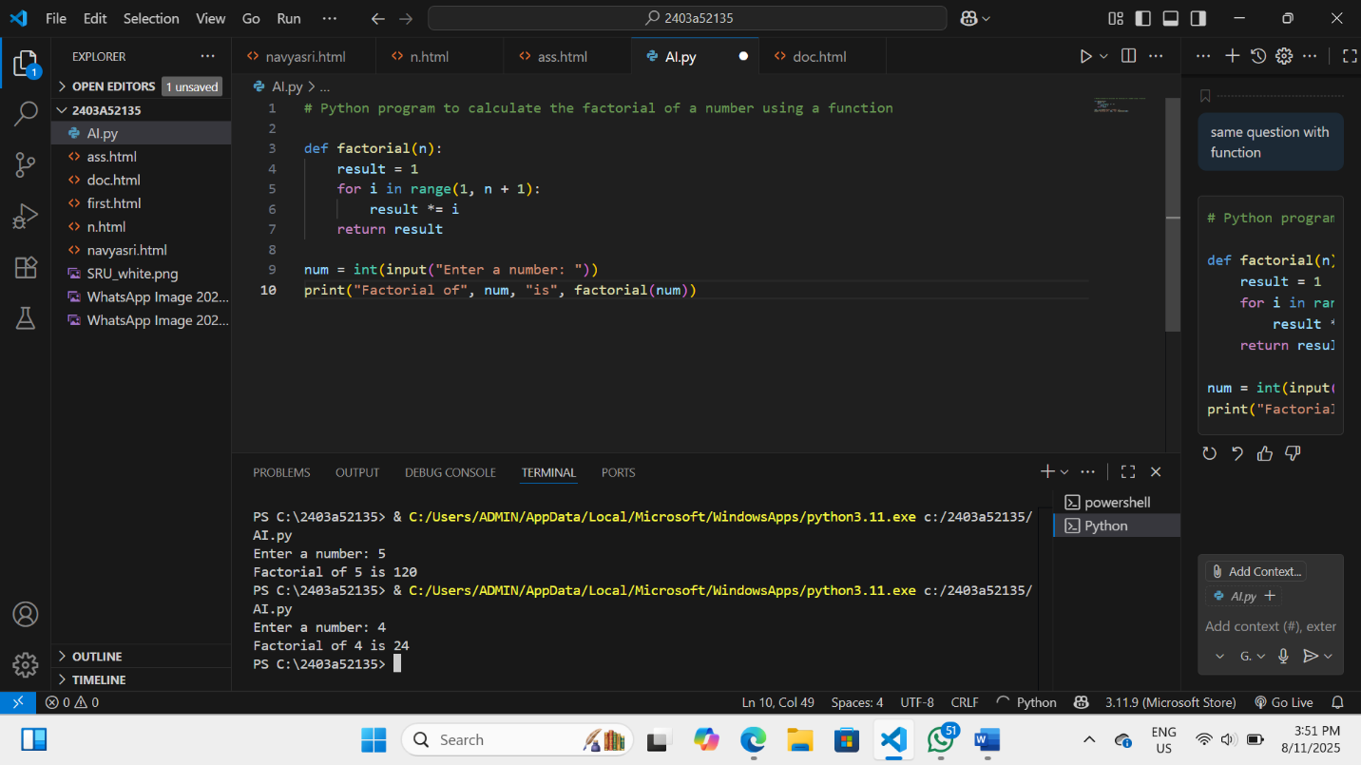

Task-4

The main difference is:

* **First code:** Calculates the factorial directly in the main code using a loop, without defining any function.
* **Second code:** Uses a separate function (factorial) to calculate the factorial, making the code reusable and organized. The main code calls this function.

**Summary:**

* First: No function, logic is in the main code.
* Second: Uses a function for calculation.

Task-5

